**ELON MUSK**

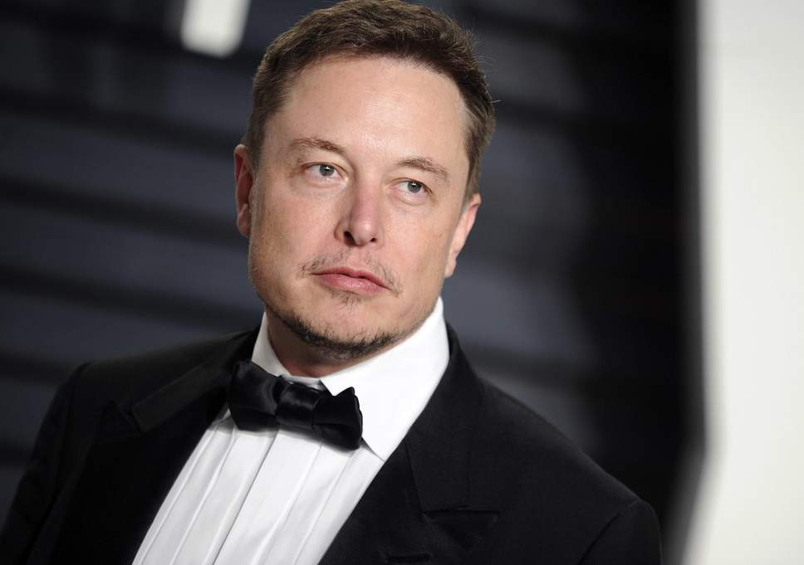

**South African-Canadian-American having thinking of**

* **Far-sightedness**
* **Futuristic**
* **Barrier-Free-Thinking.**

“MAKE YOURSELF CHANGE WHICH YOU WANT TO SEE IN THIS WORLD”

**The above statement was said by ‘Mahatma Gandhi’ but the person who followed this thought is –** ELON MUSK.

“THE PERSON WHO PROMISED TO SEND HUMANS ON MARS BY 2030”

Today we will look out the life story or biography of the greatest brave revolutionary (Kranti-kaari) of this century in the field of technology.

Elon Musk always has the thinking for solving the humans problems and issues. Due to this reasons he is also known as “Genius Entrepreneur”.

For more helpful and useful posts, visit our blog by clicking here

<https://learn-all-about.blogspot.com/>

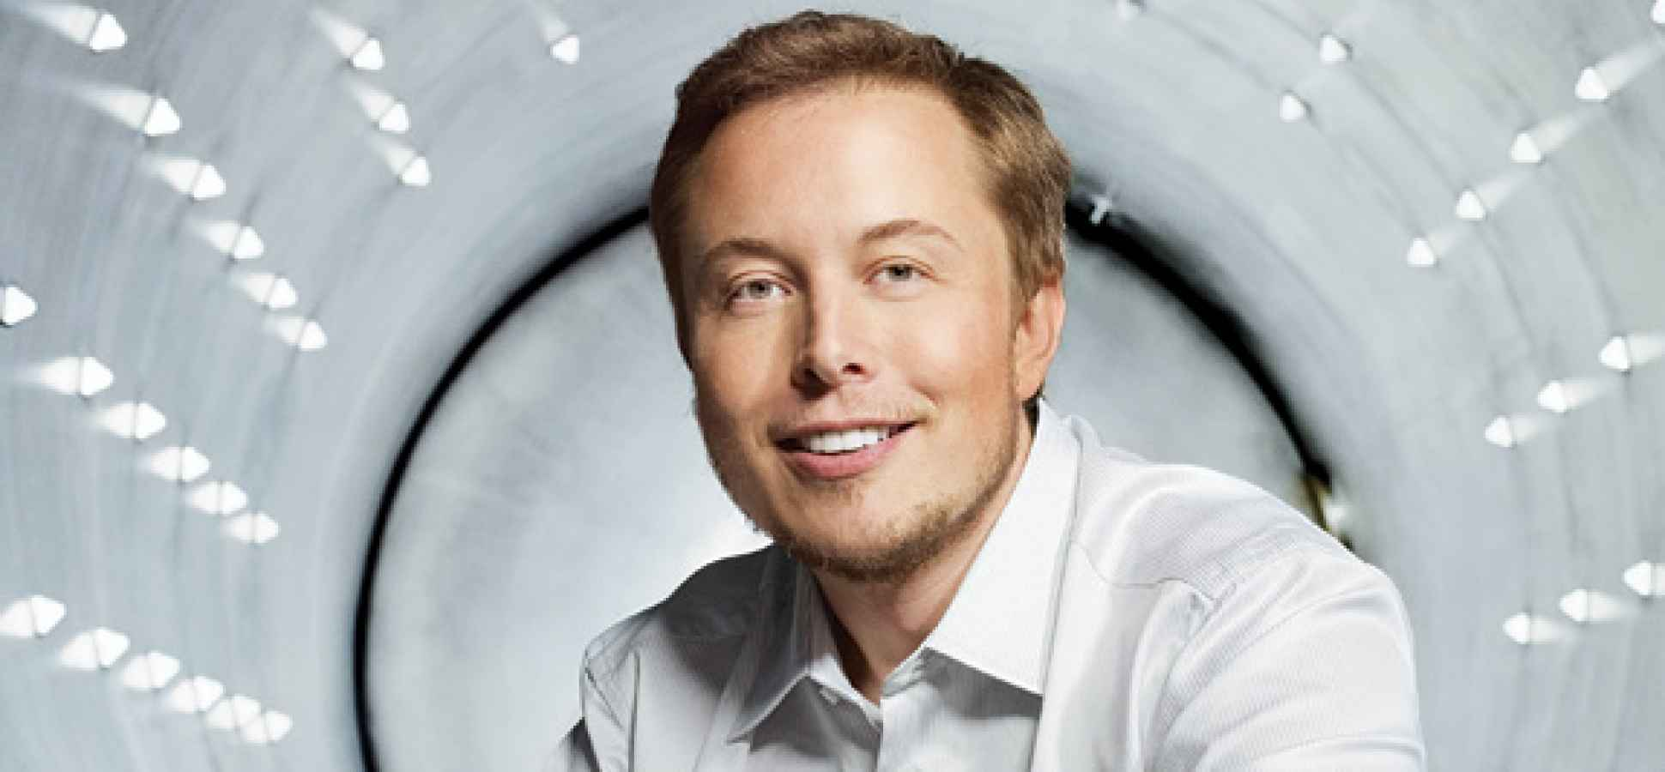

According to Forbes Listing , he is World’s #21 Richest Person. But as we know ‘ROME WAS NOT BUILT IN A DAY’, this is not easy for anyone but Elon Musk has struggled in his whole life part and his struggles towards his all dedication gets success which can’t be done by easily.

But according to Elon Musk:-

“LOOKING FOR THE SOLUTION IS THE BIGGEST PROBLEM IN THE WORLD”

So Guys, the story begins nearly 46 years ago when the city of South Africa named as Pretoria on 28 June 1971 where Elon Musk was born. His father name was Errol Musk and he was an engineer as well as pilot. Whereas his mother name was Maye Musk, who was a model and a dietician.

Elon Musk had an interest of studying from his earlier childhood and he was always found near the books and at library. At the age of 10 years he had learned computer programming language and at the early age of 12 years he made a computer game which was named as ‘Blasters’ which was sold for $500 to PC & OFFICE TECHNOLOGY COMPANY. From here at this age the talent of Elon was started in technology and gadgets. In his childhood he was use to study books of ‘Isaac Asimov’ from where he was inspired towards technology world.

During school time he was harassed and also ragged several time. Once he was throwed by some bully guys from the staircase and then they have bitted Elon until he was became an unconscious, due to these some several incidents he has to admitted in hospital for many couples of days. Though he was suffered so many worse experience but later than he has always done many things in the favour of human rights and comforts in the technology.

The Bachelor Education of Elon was started from QUEEN UNIVERSITY, but after 2 years he was transferred to UNIVERSITY OF PENNSYLVANIA where he had taken the degree in Physics of Bachelor of Science in 1992 and later on in 1995 he was shifted to California for further study of PhD. But after two days of transferred, he decided to taking a drop from study and started to become a successful businessman. So, in 1995 with his brother Kimbal , Elon started a software company as ZIPP2 which was later on sold to COMPANQ company due to .com domain crises at $307 Million large amount. He has shared of 7% in ZIPP2 company which has an amount of total $22 Million.

In 1999 , Elon invested around $10 Millions to founded X.COM company which was a financial service provided company and after a year, this was joined to CONFINITY company and started new money transfer service providing company which we are know it by PAYPAL and from that days to till today PAYPAL is most popular money transferring medium in the world. In 2002 , eBay bought PAYPAL at an unbelievable amount of $1.5 Billions . From this deal, Elon got $165 Millions as he has largest shares of PAYPAL.

After that all, he started thinking of making space agency to grow plants and trees and to send humans on Mars planet. He went to Russian Space Agency to make such aero-vehicles from which humans can go to Mars. From his request, Russian Space Agency sent a proposal to Elon Musk to make that aero-space vehicles in budget of $8 Millions but he tried to negotiate it , later on due to several negotiation issues, they rejected Elon’s Project. He went to home and started thinking to make such company by own. He started studying Rocket Science from books. In 2002, he invested $100 Millions and founded SPACEX company and it is manufacturing space launching vehicles as like Henry Ford had started created Commercially Viable Automobile Industry which is known as FORD. Elon inspired from Henry Ford as he started Car Assembly Lines likewise Elon also thought to make Space Assembly Line. He thought to make reusable rockets but nobody believes him because it is very difficult to manufacture cheap rockets with reusable. At first launch of Rocket, it was burnt early , on second try rocket launched in space but it cant reached orbit and on third try it became off route after launch. Now all the invested money of him was spent and nobody helped him but Elon has never gave up and said to try one more time and on very next try he succeed .With this he got project of $1.5 Billion from NASA. Once Elon has said in an interview that by 2030, he is trying to settle humans on Mars planet.

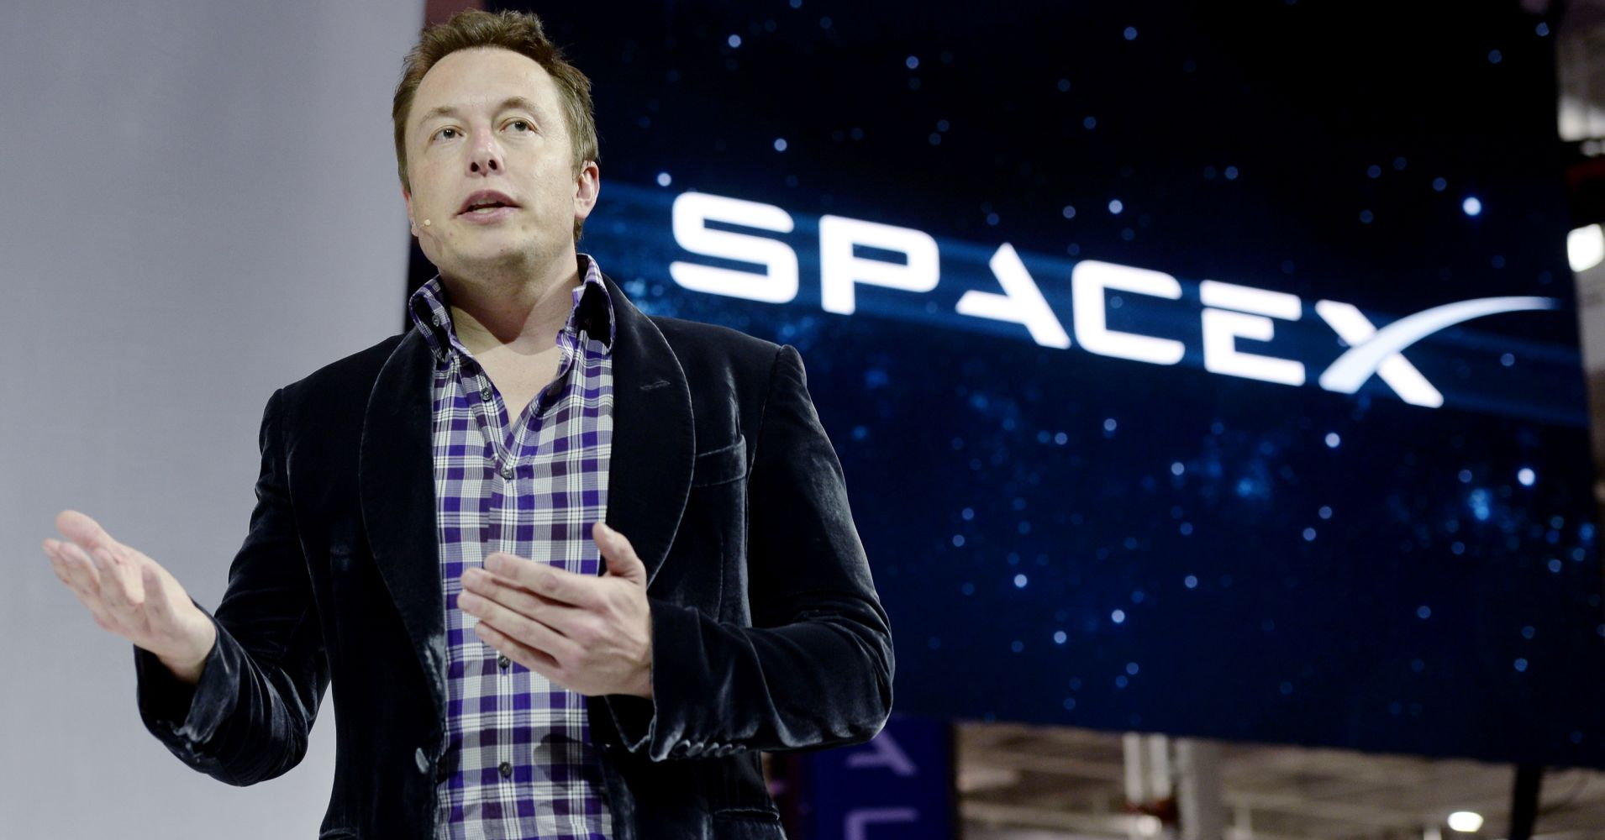

In 2003, with two other members, he co-founded TESLA motors which is an automobile company. From 2008, he is worked as CEO at TESLA motors. As we know, TESLA motors is popular for electric cars and driverless cars which is pollution free. In 2006, Elon associates his cousin’s company SOLARCITY to transfer as financial capital and helped to build up. In 2013, SOLARCITY became second most Solar Power System to provide Solar Power in USA. In 2016, SOLARCITY was taken under to associate with TESLA. In December 2015, Elon started new company for artificial intelligence which was named as OpenAI. In 2016, Elon Musk has co-founded NEURALINK company , which works on to connect Artificial Intelligence Robots to the Human Brian.

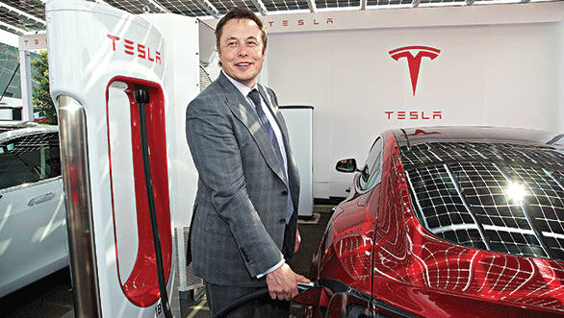

ELON MUSK SAID:-

“I DON’T EXPECT TO DO WHAT IS POSSIBLE, I WANT TO DO WHAT IS NEEDED TO BE DONE.”

SOME MAJOR COMPANIES LIST OF ELON MUSK ARE:

* ZIP2
* PAYPAL
* SPACEX
* TESLA
* SOLARCITY
* HYPERLOOP | ONE
* OPENAI
* NEURALINK
* THE BORING COMPANY.

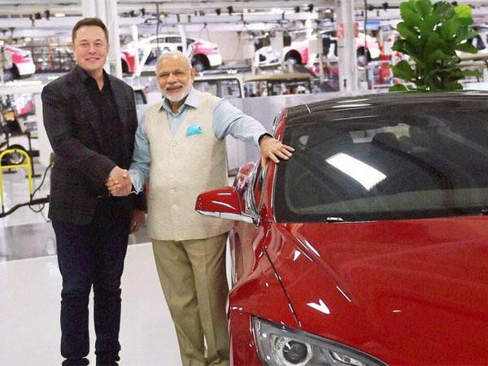

NOW TESLA motors also started investing in India. When Indian Prime Minister Narendra Modi met Elon, he promised to make pollution free and petrol-less vehicles by the request of Narendra Modi to make India Green & Clean.

For more helpful and useful posts, visit our blog by clicking here

<https://learn-all-about.blogspot.com/>